**Assignment 3**

**Aim:** Write a web based application and use firebase.

**Theory:**

Firebase is a toolset to “build, improve, and grow your app”, and the tools it gives you cover a large portion of the services that developers would normally have to build themselves, but don’t really want to build, because they’d rather be focusing on the app experience itself. This includes things like analytics, authentication, databases, configuration, file storage, push messaging, and the list goes on. The services are hosted in the cloud, and scale with little to no effort on the part of the developer.

**Why use Firebase?**

This is different than traditional app development, which typically involves writing *both* frontend and backend software. The frontend code just invokes API endpoints exposed by the backend, and the backend code actually does the work. However, with Firebase products, the traditional backend is bypassed, putting the work into the client. Administrative access to each of these products is provided by the [Firebase console](http://console.firebase.google.com/).

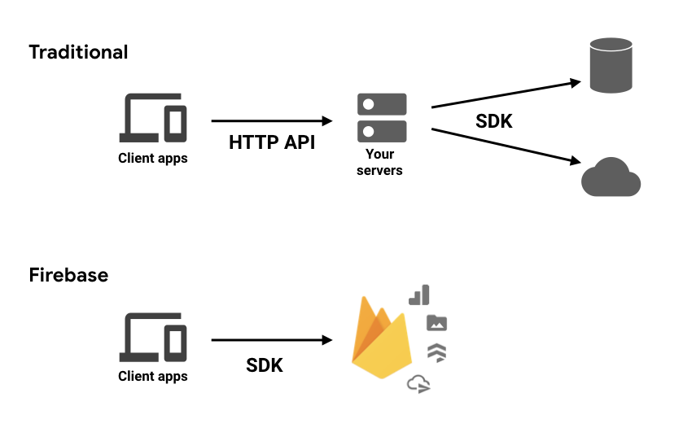

**What sort of apps is Firebase good for?**

There’s really no limit to the *types* of apps that can be helped by Firebase products. There are only limits to the platforms it can be used on. [iOS](https://firebase.google.com/docs/ios/setup) and [Android](https://firebase.google.com/docs/android/setup) are the primary targets for the Firebase SDKs, and there’s increasing support for [web](https://firebase.google.com/docs/web/setup), [Flutter](https://firebase.google.com/docs/flutter/setup), [Unity](https://firebase.google.com/docs/unity/setup), and [C++](https://firebase.google.com/docs/cpp/setup). You should also know there’s an [Admin SDK](https://firebase.google.com/docs/admin/setup) available for a variety of languages, to be used with any backend components you might require.

On top of those SDKs, there’s a library called FirebaseUI ([Android](https://github.com/firebase/FirebaseUI-Android), [iOS](https://github.com/firebase/firebaseui-ios), [web](https://github.com/firebase/firebaseui-web)) that provides a bunch of helpful utilities to make development with Firebase even easier. And there are also projects such as [AngularFire](https://github.com/angular/angularfire2) that wrap the web SDKs for use with Angular. These are open source. [Firebase likes open source.](https://firebaseopensource.com/)

The “build” group of products are these:

Authentication — user login and identity  
Realtime Database — realtime, cloud hosted, NoSQL database  
Cloud Firestore — realtime, cloud hosted, NoSQL database  
Cloud Storage — massively scalable file storage  
Cloud Functions — “serverless”, event driven backend  
Firebase Hosting — global web hosting  
ML Kit —SDK for common ML tasks

**Firebase Features**

* Real-time Database − Firebase supports JSON data and all users connected to it receive live updates after every change.
* Hosting − The applications can be deployed over secured connection to Firebase servers.

**Firebase Advantages**

* It is simple and user friendly. No need for complicated configuration.
* The data is real-time, which means that every change will automatically update connected clients.
* Firebase offers simple control dashboard.
* There are a number of useful services to choose.

**Firebase Limitations**

* Firebase free plan is limited to 50 Connections and 100 MB of storage.
* The Firebase data is representing JSON objects. If you open your app from Firebase dashboard, you can add data manually
* Firebase auth has a built in email/password authentication system. It also supports OAuth2 for Google, Facebook, Twitter and GitHub. We’ll focus on email/password authentication for the most part. Firebase’s OAuth2 system is well-documented and mostly copy/paste.
* Firebase includes an easy-to-use hosting service for all of your static files. It serves them from a global CDN with HTTP/2.
* Firebase hosting utilizes [Superstatic](https://github.com/firebase/superstatic), which you can run locally for all of your testing.
* The BrowserSync + Superstatic development environment is slick. BrowserSync handles reloading your development app across all connected devices and Superstatic replicates Firebase hosting locally in such a way that you can deploy straight to Firebase for production use.

**IMPLEMENTATION**

**Step 1:** Go to firebase.google.com & click on Get started

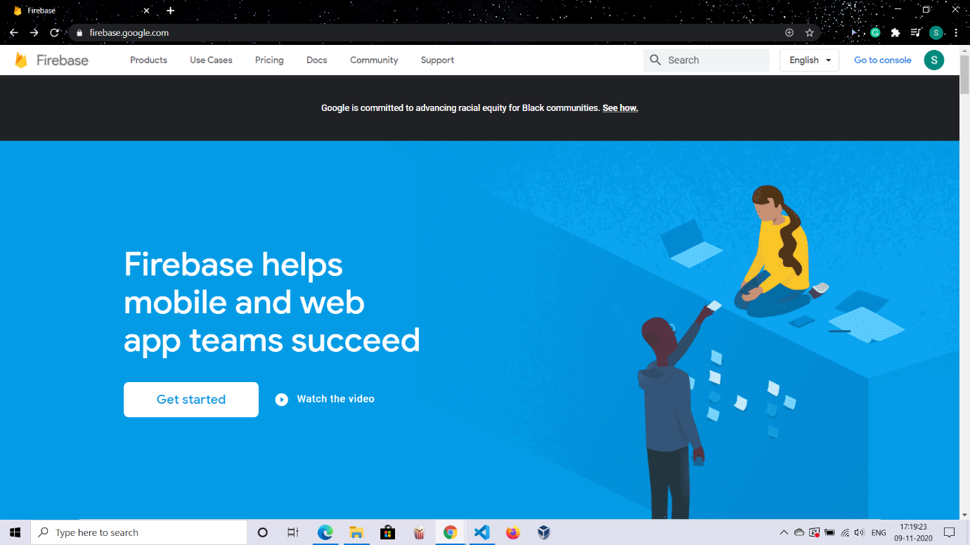

**Step 2:** You will be taken to a page which asks for your project name.

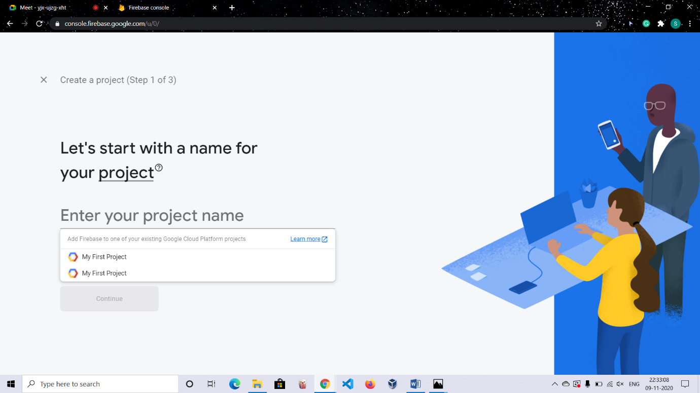

**Step 3:** Enter the name , accept terms and click Continue

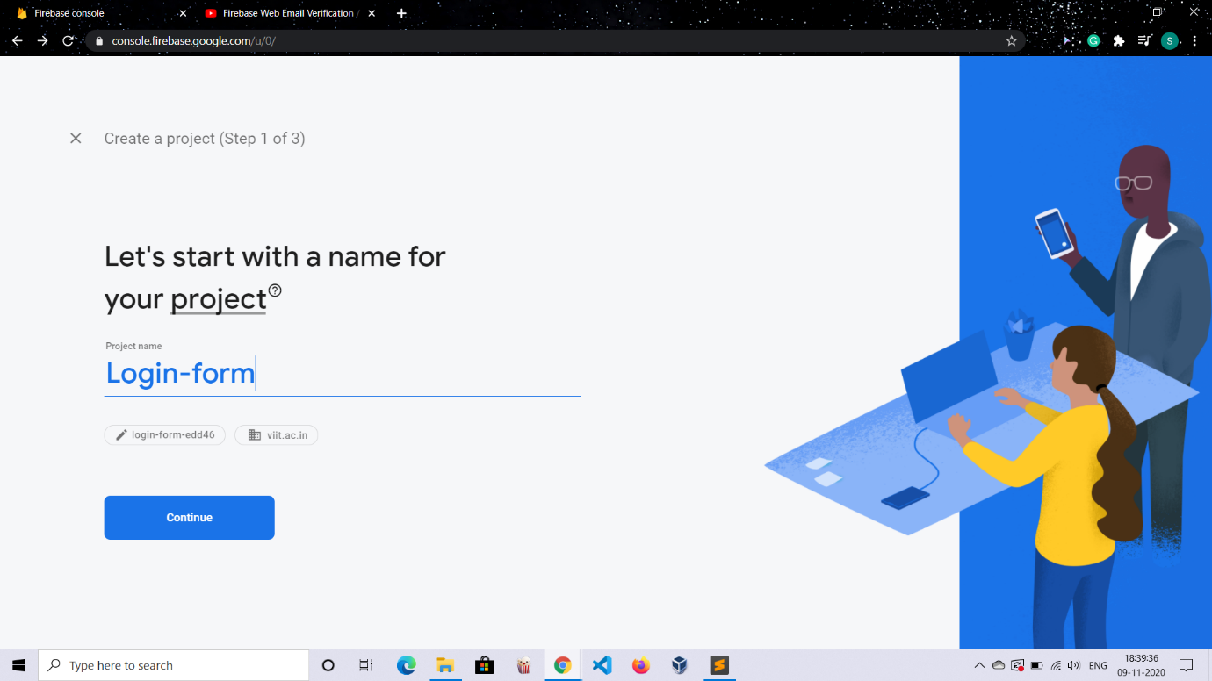

**Step 4:** Enter location, check the default settings for sharing Google analytics data, accept terms & click create project

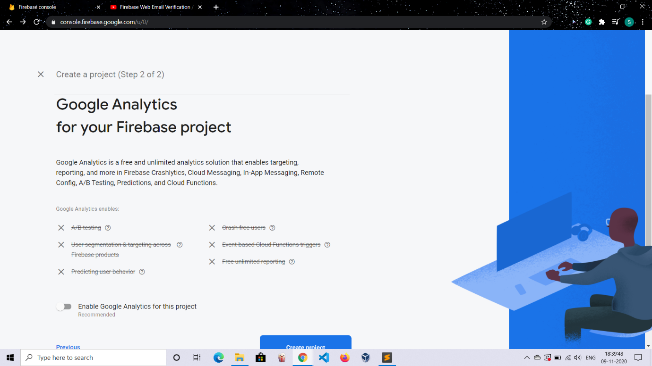

**Step 5:** Your project will be created

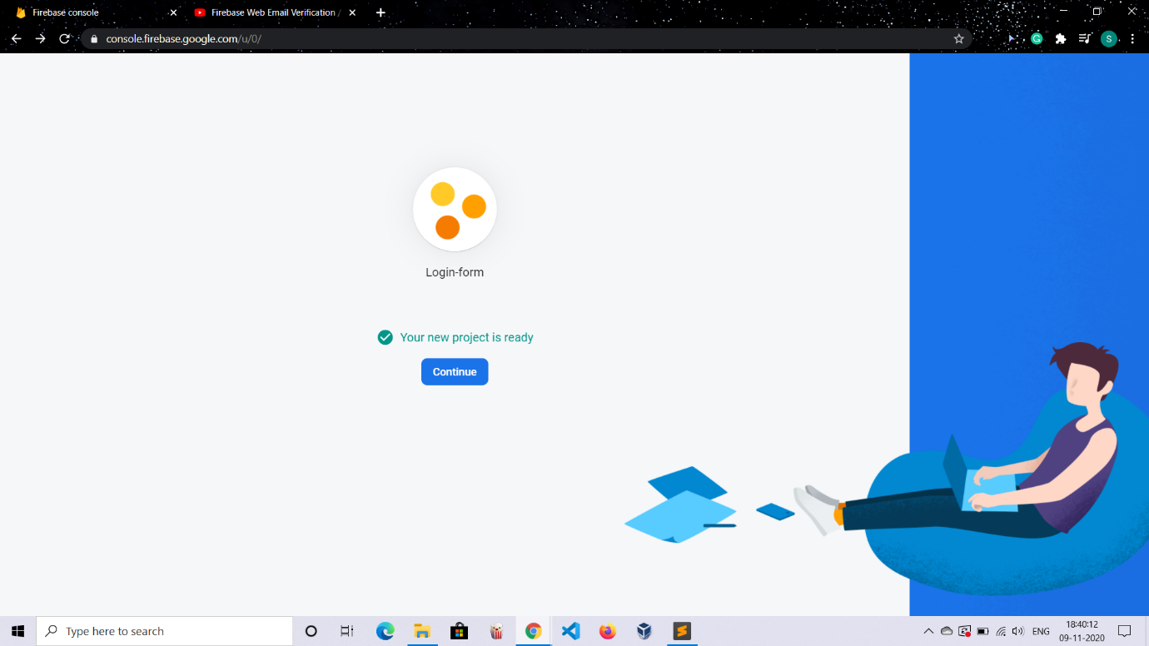

**Step 6:** Click Continue

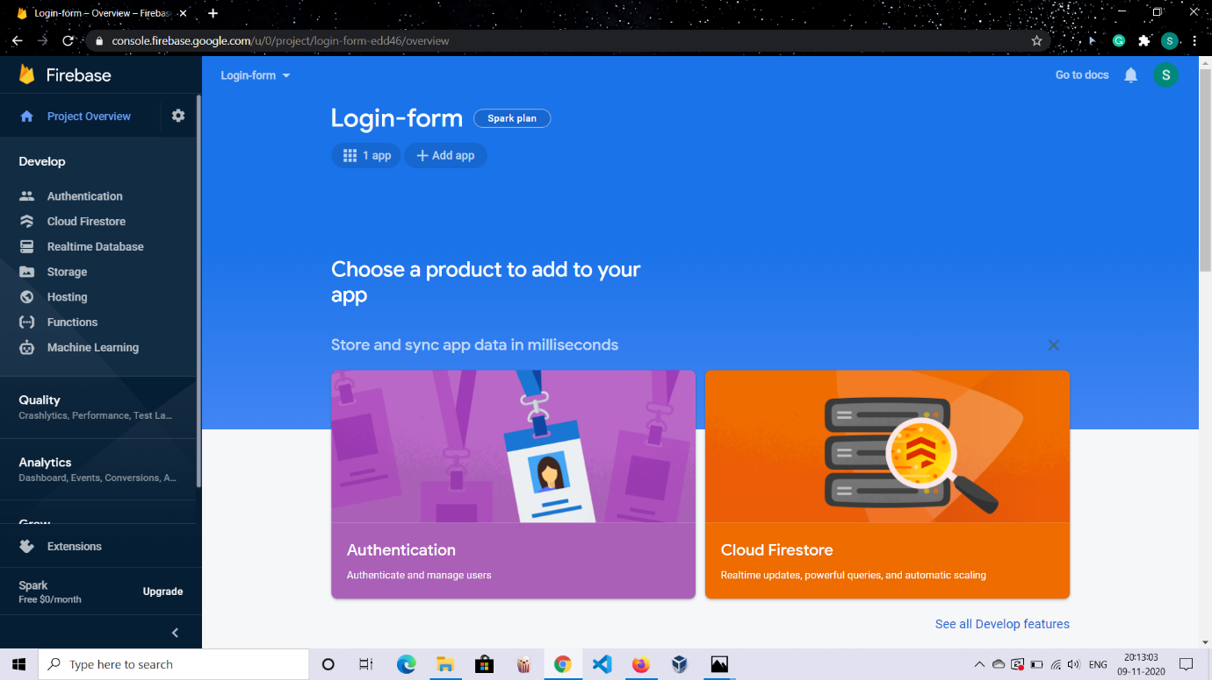

**Step 7:** Click on WEB

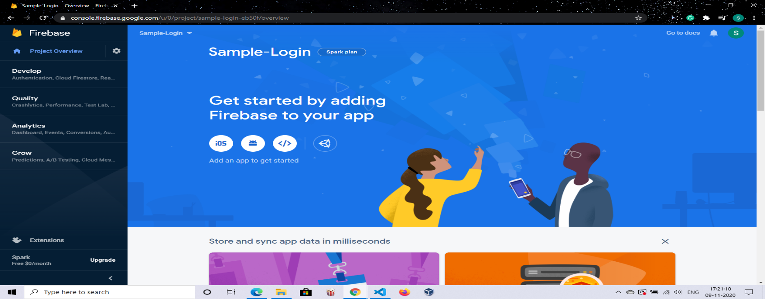

**Step 8:** Go to code and copy paste this snippet to code in html as well as javascript files

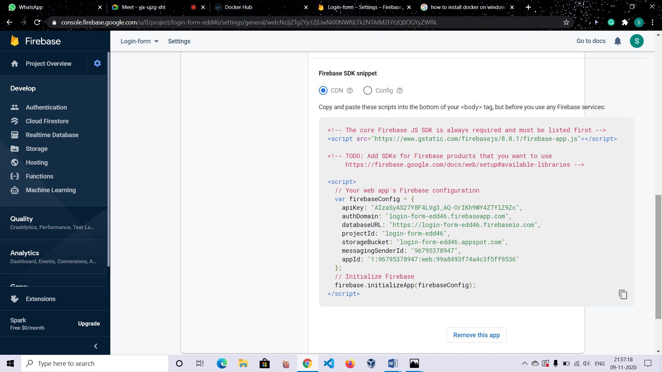

I ) html

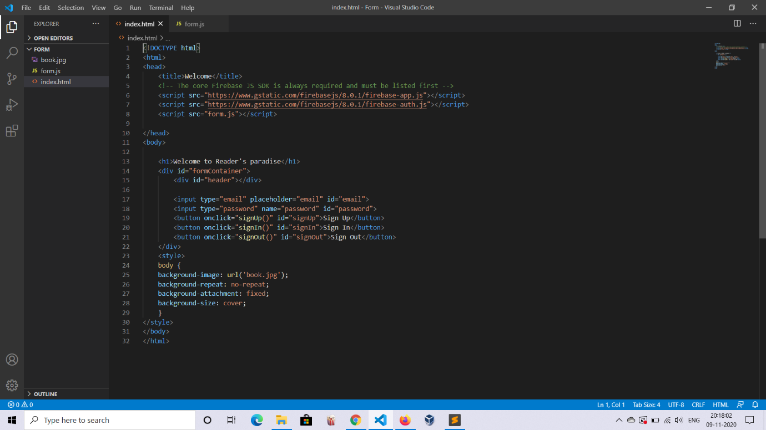

II ) Javascript

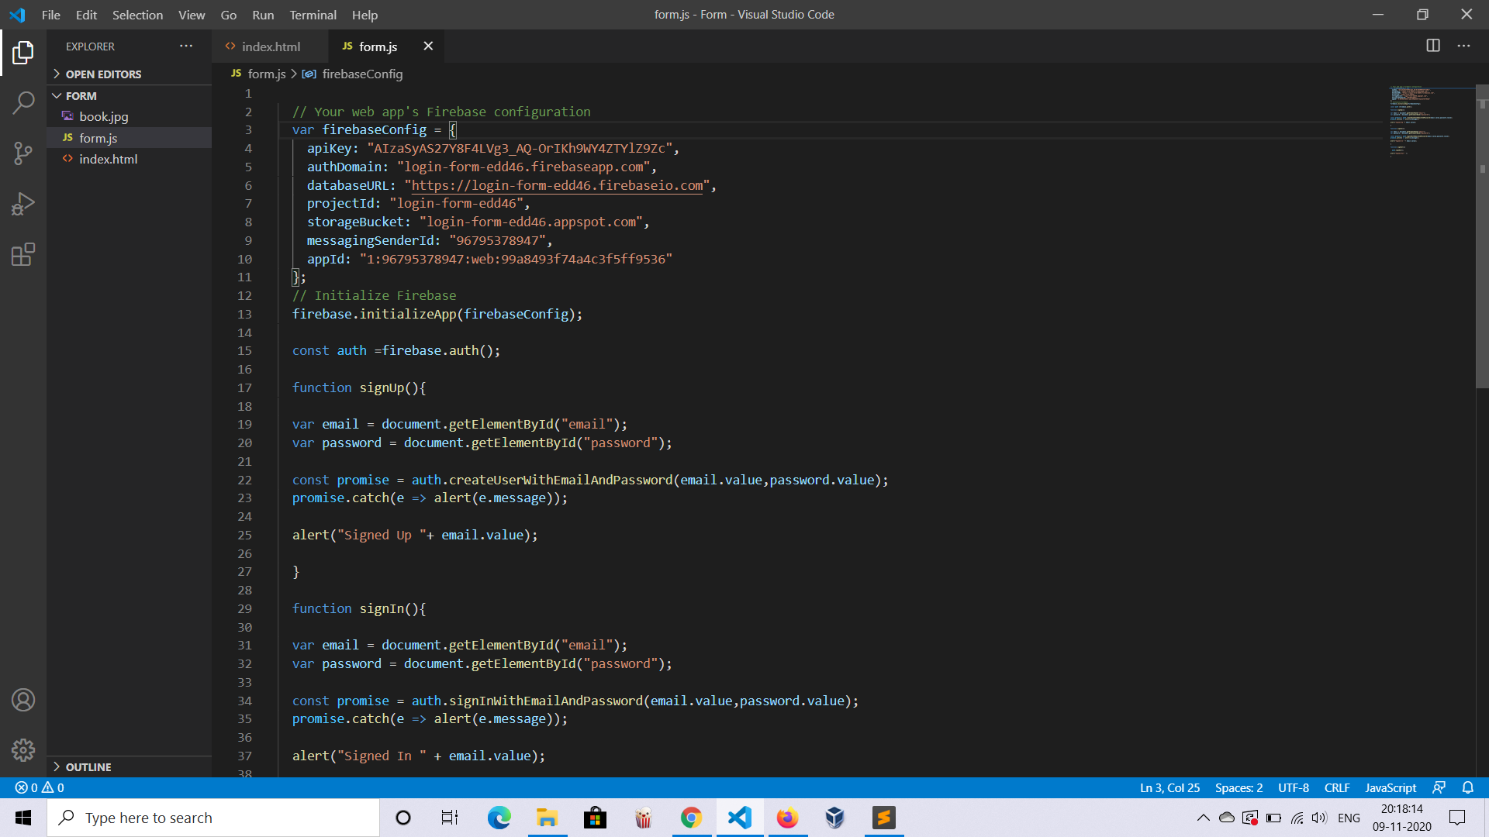

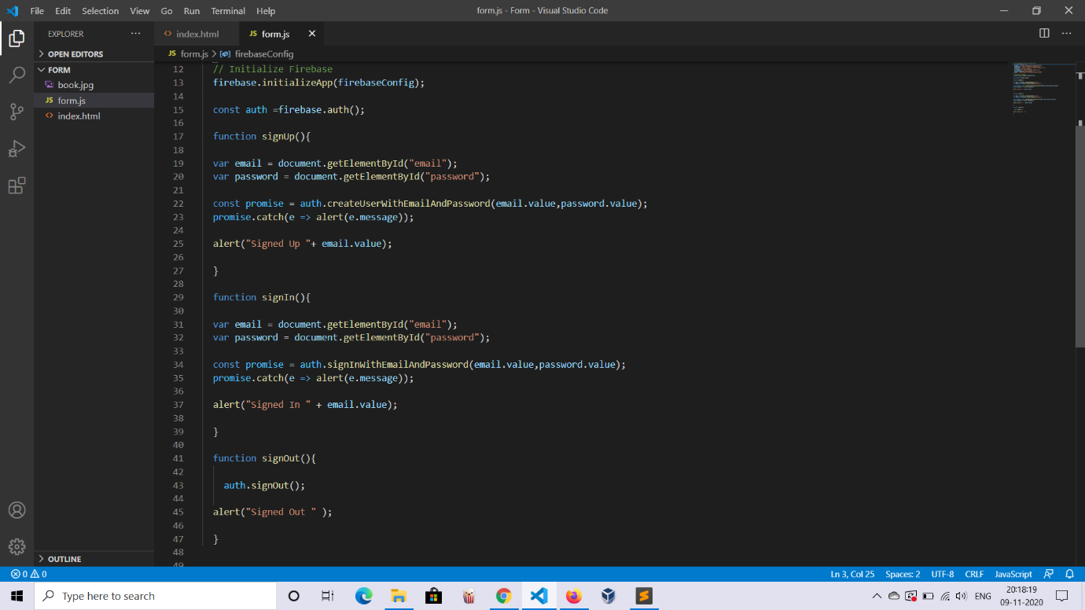

**Step 10:** Go to Authentication on console page & click on Get Started. Right now there are no users registered hence the user section is empty

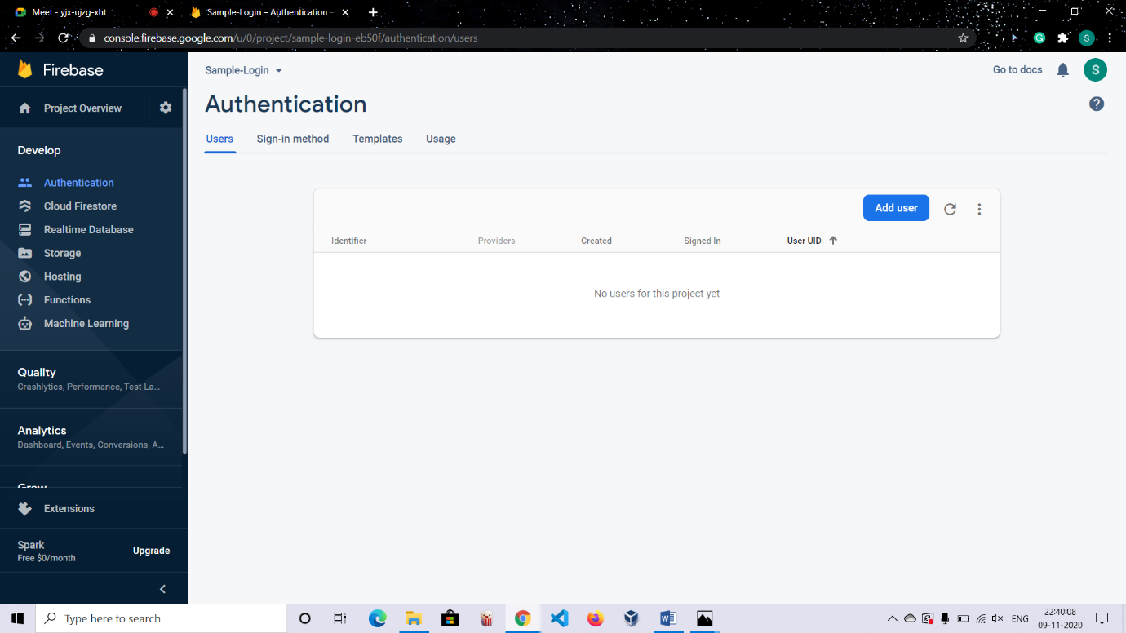

In next step is sign-in method with various options such as Phone,Goggle and many more

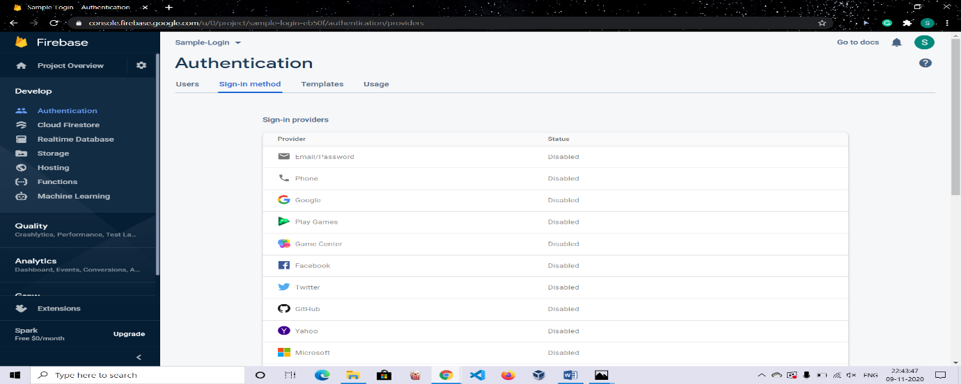

**Step 11:** To enable any of them, click on the edit icon beside it. Here, I chosen Email/Password verification.

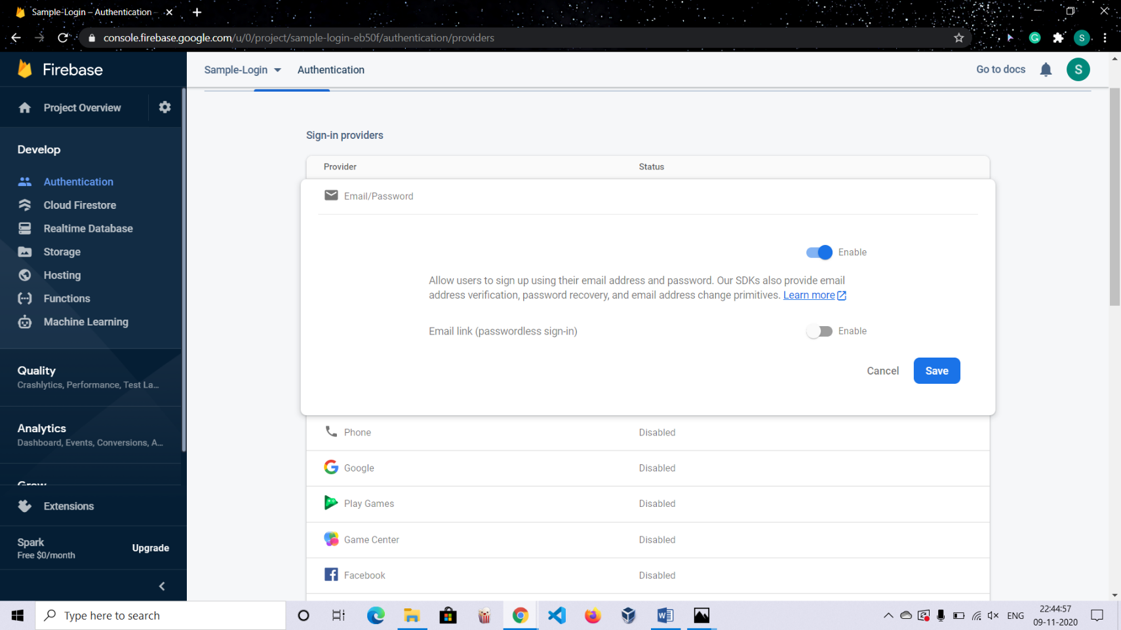

**Step 12:** Email/Password authentication is now activated.

**Step 13:** Go to Website and enter an email id and password



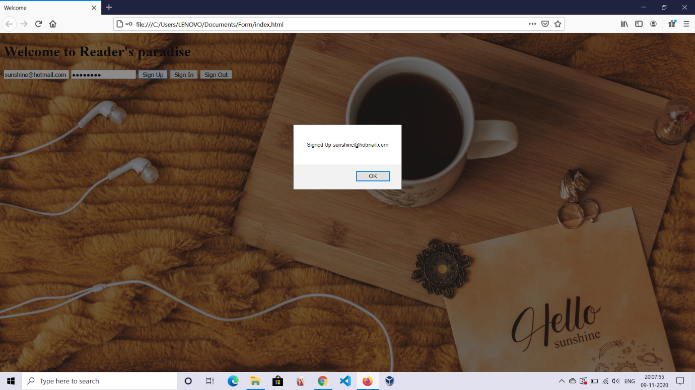

**Step 14:** Users list before and after adding a new user

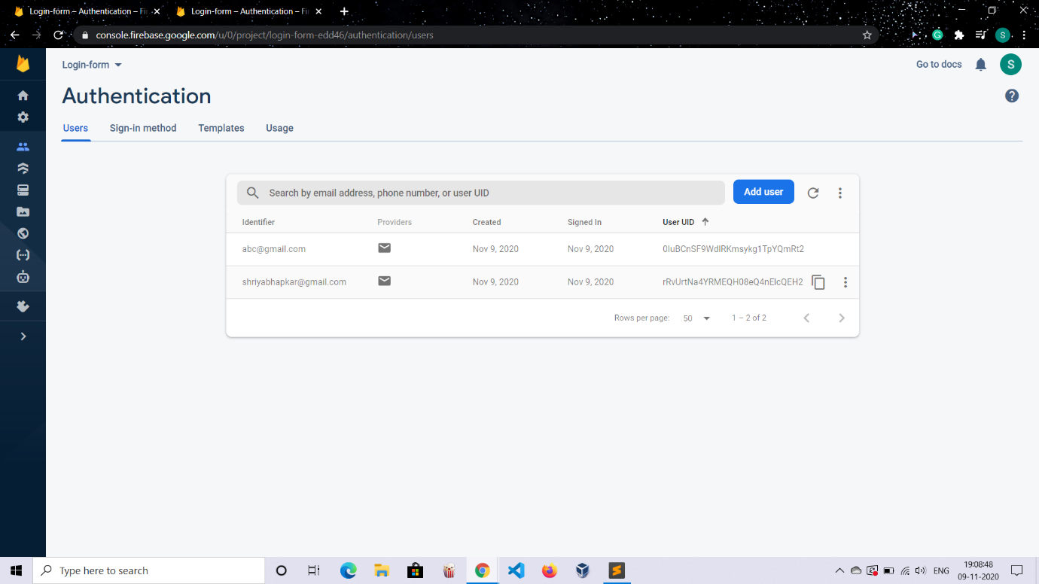

After

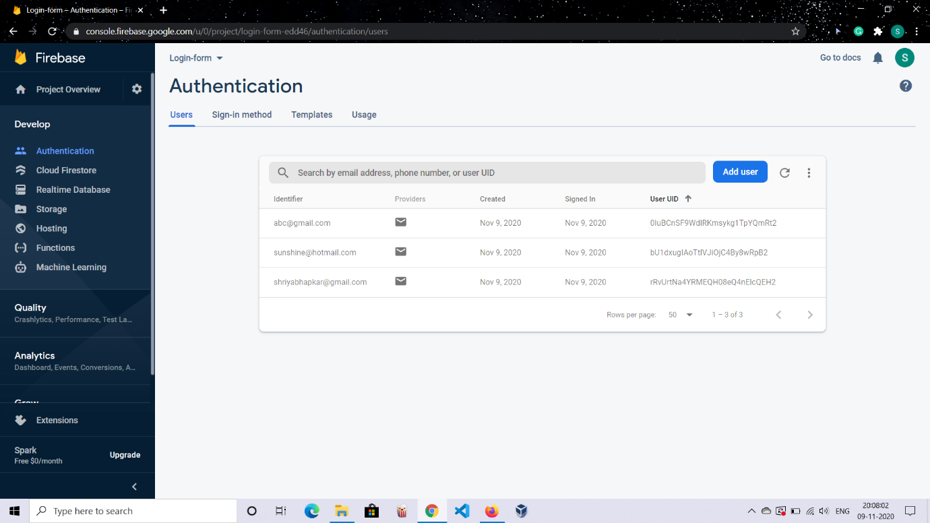

Searching for an account can be done using email address, phone number or user UID.

Here I have searched using email address

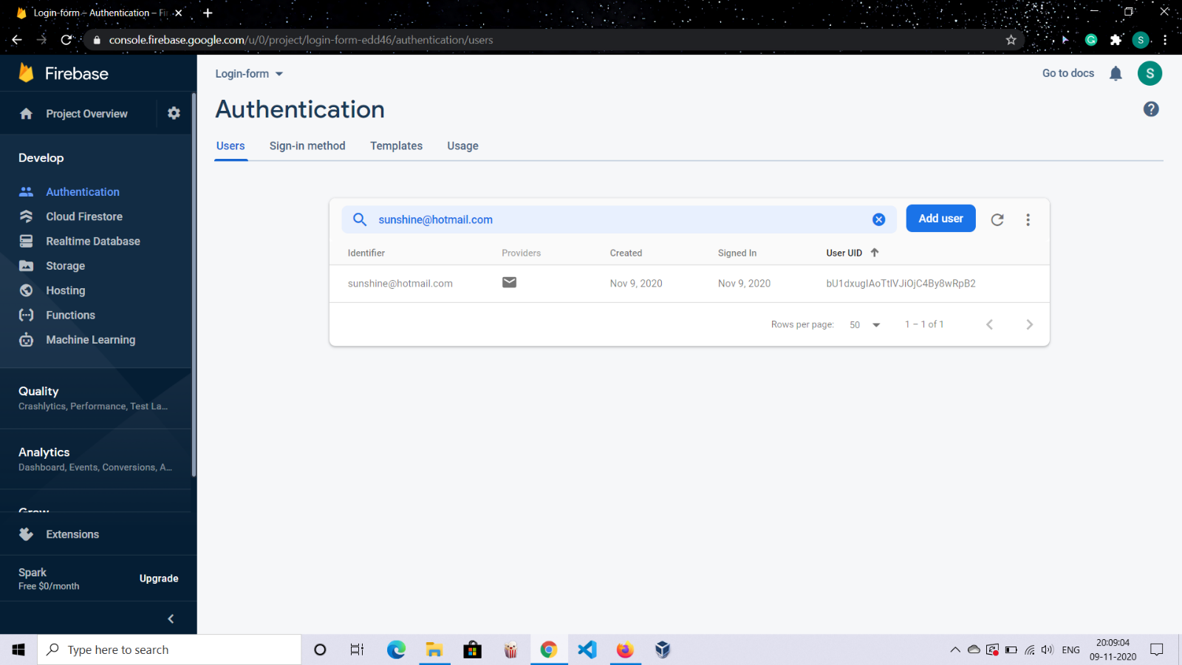

**Conclusion**: A web based application for login using firebase was implemented successfully.